CERTIFICATE OF CONFORMITY TO OEM REFERENCE

Juratek Product Reference | MER143
Product Description | Brake Disc
OE Part Number | 6754210012
Application(s): | Mercedes Axles
Supplier Quality Approval | BS EN ISO9001: 2008

We certify that the goods detailed above conform to the material & dimensional specifications required by Juratek Ltd and that they are fit for direct OEM replacement.

Print Name: | Andrew Kibler
Signed: | 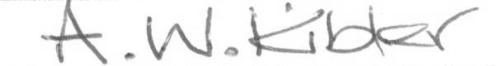
Position: | Quality & Engineering Manager
Date: | 30 July 2026

